

IOT Development Agreement

Agreement
This Agreement is made on Date : 27/ 07 / 2026

Between
S&T Machineries Ltd
(No. 60/2, 3, Mahatma Gandhi Rd, Near SIHS Colony, Neelikonampalayam, TamilNadu - 641033)

TABLE OF CONTENTS

Index
S.No | Description | Pg.no
1 | Definitions & Parties | 4
2 | Purpose of Agreement | 4
3 | Project Background | 4
4 | Scope of Phase 1 – PMS/I4.0 Development | 5
5 | Detailed Scope of Work (Annexure A) | 5
6 | Project Phases & Deliverables | 19
7 | Team & Responsibilities | 19
8 | Timeline | 20
9 | Commercials & Payment Terms | 20
10 | Dependencies & Out of Scope Items | 20
11 | Acceptance Criteria | 21
12 | Intellectual Property Rights (IPR) | 21
13 | Confidentiality | 21
14 | Non-Solicitation Clause | 21
15 | Change Request Procedure | 21
16 | Support & Warranty | 22
17 | Termination | 22
18 | Penalties & Damages | 22
19 | Governing Law & Jurisdiction | 22
20 | Entire Agreement | 23
21 | Signature Page | 23

Document Details
Revision History

V1.0 | 10 January 2026 | Basic Version
V2.0 | 25 July 2026 | Advanced Version

Reference
Scope of work in phase2 with Advanced Overall Production Monitoring System, Maintenance Monitoring System, Programs Transfer, Energy Monitoring System, Discussions on 10th July with Presentation & Direct visit to the STM Factory.

Objective & Scope of Work Objective:
The objective of this document is to outline the Scope of Work and Deliverables sign off for the custom development of Advanced Production Monitoring System (I4.0) for S&T Machinery, SingaNallur, Coimbatore by freelance method. This proposal highlights the dependencies, assumptions, cost, and schedule for the overall solution. This document overrides all the earlier documents and is based on current understanding and discussions on 10 July 26.

Background:

S & T Machinery is one of the most renowned Machine tool manufacturers of India. S&T Machinery produces quality metal cutting CNC machines
Consultant Mr.Gokul is in the development of IoT for shop floor digitization dashboards, they are integrating FANUC, Mitsubishi CNC machines and developing IoT products, integrating Information Technology (IT) and Operations Technology (OT)

System Overview & High-Level Specification

The diagram below shows the Ethernet network connection of the different components and specifications of the system. For simplicity, 2 machines in line 1 with the required connectivity are shown below. New Fanuc Ethernet machines can be directly connected in Ethernet Port. But other make requires the communication to be enabled by vendor (OPC UA or MT Connect) for example to be done at customer cost.

Typical Server specification

Users | OS Platform | CPU Server Model ( Physical server)
2 | Windows Server 2022 | HPE ProLiant DL380 Gen10 2U Server,2 x Intel Xeon Silver 4114/ 20 Core, 40vCPU/128 GB Memory( 4 x 32GB ) , 3 x 1.92 TB SSD , P408i-  a Ctrlr with 96W battery,rail kit,4x1 GbE Ethernet , iLO Advanced , 2x800 W Power Supply

Scope:
The Features, Requirements, Calculations, Andon board are presented in Annexure 1.
- Production Monitoring system - Overall Shop floor Performance Dashboard
- Individual Machine Status Dashboard.
- Reports - Shift-wise Reports, Hourly Reports, Operator-wise Reports, Component-wise Reports, Cycle Time Monitoring.
- Downtime Monitoring - Downtime Loss Analysis, Downtime Reason Code Entry (Operator Input)
- Live OEE Monitoring - OEE Analysis
- Program Transfer Tool
- Mobile Application - Android, IOS
- Role-Based Login & Access Control
- Dashboard & KPI Analytics
- Historical Data Reports
- Production Trend Analysis
- Alarms - Real-Time Alerts & Notifications, Alarms Live Monitoring
- Machine Interlock System
- Maintenance Monitoring System - Preventive, Periodic Monitoring System
- Energy Consumption Monitoring- KWh, Volts, Amps( Overall /Individual Consumption / Reports)
- AI - Chatbot Analyse - with Database Connection/ Excel

Out of Scope:
Resolving /Integration of any issue on any third-party application
Shop floor machine connectivity to Server, Power supplies, Routers, Servers, Andon TV etc., Cost of Gateway/Hardware
If Cost of OPC UA license for Siemens, MT Connect for Mitsubishi, CNC OEM -Engineer service/visit cost and timely coordination to be ensured by client at their cost.

Note:
The amount of data and update rates will differ vastly between CNC controller makes and
models. Generally, all parameters will not be applicable to all machines. Some additional data needs to be added to sensors like vibration, Oil level Float, etc.

DEFINITIONS & PARTIES
This Consulting & Software Development Agreement (“Agreement”) is executed on this day of
2026 at Coimbatore, Tamil Nadu.

Company:
S&T Machinery Private Limited
Registered Address: No. 60/2, 3, Mahatma Gandhi Rd, Near SIHS Colony, Neelikonampalayam, TamilNadu - 641033 Represented by: Saravanan S Hereinafter called “STM MEXA.”

Consultant:
Mr. Gokul
IoT - Software Development Resident: Coimbatore – 641107
Hereinafter called “Technical Software Consultant.”
Both jointly referred to as “Parties.”

PURPOSE OF AGREEMENT
Company appoints the Consultant to design, architect, develop and deliver Phase 2 – Advanced Overall Production Monitoring System, Maintenance Monitoring System, Programs Transfer, Energy Monitoring System, AI Analytics / I4.0 Solution, including all modules, dashboards, UI/UX, backend, and server integration.

PROJECT BACKGROUND
As per Company discussions dated 10 July 2026:
  - S&T Machinery manufactures CNC machines.
  - Company requires a Advanced PMS/MMS/Program Transfer/ AI Analytical/Energy Monitoring,/Alarms & Periodic Maintenance/ I4.0 system for machine monitoring.
  - Consultant (Gokul - freelance team) is developing IoT + PMS, MMS,PT, Energy soft wares.
  - Based on factory visit, presentation, and finalized requirements, scope is defined. This Agreement supersedes all previous communications.
- The platform is expanding from a single-company deployment into a multi-tenant system, serving multiple client companies (each with its own plants, lines, machines and users) from one installation.
- Company requires CNC program (DNC) transfer — pushing NC/G-code programs directly to Fanuc and Mitsubishi controllers over their built-in FTP service.
- Company requires structured alarm, ticketing and maintenance workflows (preventive and periodic), replacing informal tracking.
- Company requires a notification engine, and access to the platform from Android, iOS and Windows desktop, not only the web browser. This scope, its 44-screen breakdown, and its commercial terms were finalized in the Company's separate CNC Machine Monitoring System — Phase 2 Development Proposal.
- This Annexure documents the corresponding detailed, screen-level functional requirements. This Agreement supersedes all previous communications regarding Phase 2 scope.

Scope of Phase 2 Phase 2 includes:
- Multi-tenant Company, Plan & Access administration (Super Admin layer)
- Role-Based Access Control — four-tier hierarchy: Super Admin → Company Admin → Manager/Supervisor → Operator
- CNC Program (DNC) Transfer over FTP — Fanuc & Mitsubishi controllers
- Alarm, Ticket & Maintenance management — preventive and periodic scheduling Notification Engine — in-app and push (Firebase FCM)
- Advanced Analytics — Energy, Alarm, Operator Performance, Downtime Pareto, extending Phase 1's OEE/Reports/Charts
- Android & iOS Mobile Application (shared login with web)
- Windows Desktop Application (installable, auto-updating)
- Deployment, Go-Live and system-wide testing
Phase 3 and beyond are NOT included

DETAILED SCOPE OF WORK

44 screens across six web modules and one mobile application. Each module below shows its representative screen mockup(s) followed by numbered "shall" requirements per screen — the same format used for Phase 1.

A · Analytics Dashboards — 9

B · Program Transfer — 1

C · Company & User Admin — 10

D · Alarm, Ticket & Maintenance — 6

E · Notification Center — 3

F · Settings & Profile — 2

M · Mobile App — 13

Screen 1 - Factory Overall Dashboard Functional Requirements:

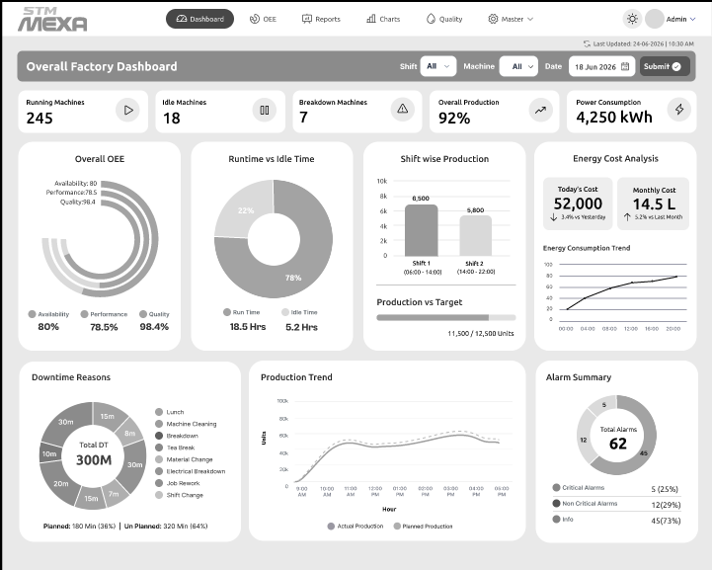

· The system shall display the Overall Factory Dashboard upon user login.
· The system shall display the total number of running machines.
· The system shall display the total number of idle machines.
· The system shall display the total number of breakdown machines.
· The system shall display the overall production percentage.
· The system shall display the total power consumption in kWh.
· The system shall display the Overall OEE, including Availability, Performance, and Quality metrics.
· The system shall display runtime and idle time in both graphical and numerical formats.
· The system shall display shift-wise production using a bar chart.
· The system shall display production against the production target.
· The system shall display daily and monthly energy costs.
· The system shall display the energy consumption trend using a line chart.
· The system shall display total downtime and categorize downtime by reason.
· The system shall display planned and unplanned downtime values.
· The system shall display production trends, including actual and planned production.
· The system shall display an alarm summary, including total alarms and alarm categories.
· The system shall classify alarms as Critical, Non-Critical, and Information.
· The system shall allow users to filter dashboard data by Shift, Machine, and Date.
· The system shall update all dashboard information based on the selected filter criteria when the user submits the request.
· The system shall display the date and time of the last dashboard update.
· The system shall provide navigation to Dashboard, OEE, Reports, Charts, Quality, and Master modules.
· The system shall display all dashboard charts and KPI values using the latest available production data.
· The system shall restrict dashboard access to authenticated users based on their assigned permissions.
· The system shall display an appropriate message when dashboard data is unavailable.

Screen 2 - Maintenance Dashboard

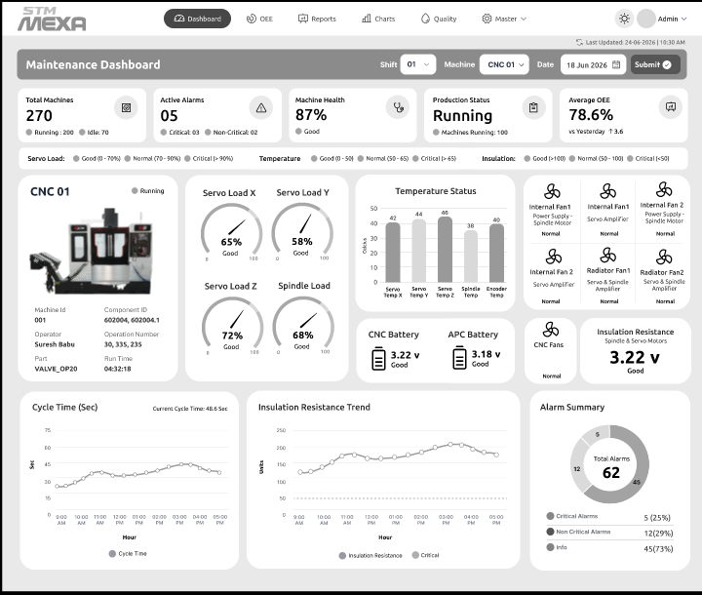

· The system shall display the Maintenance Dashboard upon user login.
· The system shall display the total number of machines.
· The system shall display the number of active alarms.
· The system shall display machine health as a percentage.
· The system shall display the production status of the selected machine.
· The system shall display the average OEE of the selected machine.
· The system shall allow users to filter dashboard data by Shift, Machine, and Date.
· The system shall update the dashboard based on the selected filter criteria when the user submits the request.
· The system shall display machine operating status.
· The system shall display machine information including Machine ID, Component ID, Operator, Part, and Run Time.
· The system shall display servo load values for each machine axis.
· The system shall display spindle load values.
· The system shall display machine temperature values for key components.
· The system shall display the battery status and voltage of CNC and APC batteries.
· The system shall display the insulation resistance value of the selected machine.
· The system shall display the operating status of machine cooling fans and amplifiers.
· The system shall display the cycle time trend using a line chart.
· The system shall display the insulation resistance trend using a line chart.
· The system shall display an alarm summary, including the total number of alarms and alarm categories.
· The system shall classify alarms as Critical, Non-Critical, and Information.
· The system shall display the date and time of the last dashboard update.
· The system shall provide navigation to Dashboard, OEE, Reports, Charts, Quality, and Master modules.
· The system shall display all maintenance data using the latest available machine data.
· The system shall restrict dashboard access to authenticated users based on their assigned permissions.
· The system shall display an appropriate message when maintenance data is unavailable.

Screen 3 - Preventive Maintenance Dashboard

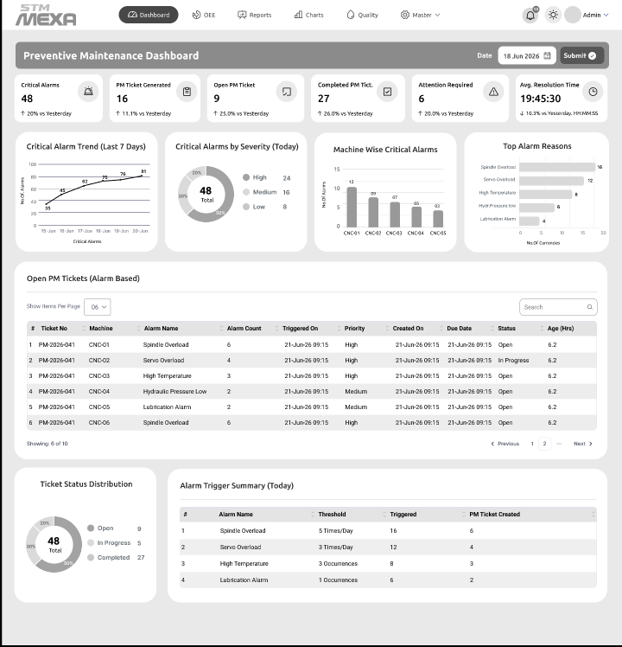

· The system shall display the Preventive Maintenance Dashboard upon user login.
· The system shall display the total number of critical alarms.
· The system shall display the total number of PM tickets generated.
· The system shall display the total number of open PM tickets.
· The system shall display the total number of completed PM tickets.
· The system shall display the total number of maintenance tickets requiring attention.
· The system shall display the average PM ticket resolution time.
· The system shall allow users to filter dashboard data by date.
· The system shall update the dashboard based on the selected date when the user submits the request.
· The system shall display the critical alarm trend for the last seven days.
· The system shall display the distribution of critical alarms by severity level.
· The system shall display the number of critical alarms for each machine.
· The system shall display the top alarm reasons based on alarm occurrences.
· The system shall display a list of open PM tickets.
· The system shall display PM ticket details, including ticket number, machine, alarm name, alarm count, triggered date and time, priority, created date, due date, status, and ticket age.
· The system shall provide search and pagination for the PM ticket list.
· The system shall display the distribution of PM ticket statuses, including Open, In Progress, and Completed.
· The system shall display an alarm trigger summary, including alarm name, threshold, number of triggers, and PM tickets created.
· The system shall display the date and time of the last dashboard update.
· The system shall provide navigation to Dashboard, OEE, Reports, Charts, Quality, and Master modules.
· The system shall display preventive maintenance data using the latest available machine data.
· The system shall restrict dashboard access to authenticated users based on their assigned permissions.
· The system shall display an appropriate message when preventive maintenance data is unavailable.

Screen 4 - Periodic Maintenance Dashboard

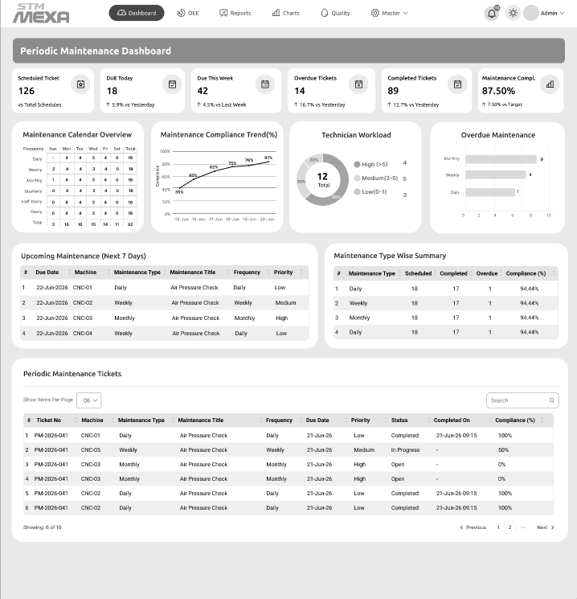

- The system shall display a dashboard summarizing periodic maintenance KPIs including Scheduled, Due Today, Due This Week, Overdue, Completed, and Compliance.
- The system shall automatically generate and manage periodic maintenance schedules based on configured maintenance frequencies.
- The system shall provide a maintenance calendar showing Daily, Weekly, Monthly, Quarterly, Half-Yearly, and Yearly maintenance schedules.
- The system shall display maintenance compliance trends and performance using graphical charts.
- The system shall display technician workload and overdue maintenance summaries.
- The system shall display upcoming maintenance activities with machine, maintenance type, due date, frequency, and priority.
- The system shall maintain and display maintenance ticket details including ticket number, machine, status, priority, due date, and completion date.
- The system shall calculate and display maintenance compliance for each maintenance activity and maintenance type.
- The system shall provide search, sorting, filtering, and pagination for maintenance records.
- The system shall generate notifications and alerts for upcoming and overdue maintenance activities.
- The system shall generate and export maintenance reports in Excel, CSV, and PDF formats.
- The system shall maintain complete maintenance history and audit logs for each machine.
- The system shall provide role-based access control for authorized users.
- The system shall support attachment of maintenance checklists, images, and documents to maintenance records.
- The system shall provide real-time dashboard updates and drill-down capability for detailed maintenance analysis.

Screen 5 - Alarm Dashboard & Reports

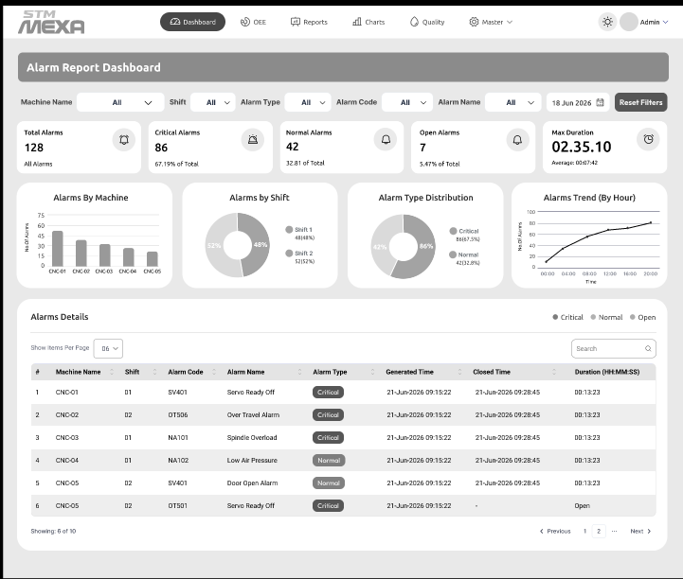

· The system shall display an Alarm Report Dashboard with real-time alarm monitoring and summary information.
· The system shall allow users to filter alarms by Machine Name, Shift, Alarm Type, Alarm Code, Alarm Name, and Date.
· The system shall display alarm KPIs including Total Alarms, Critical Alarms, Normal Alarms, Open Alarms, and Maximum Alarm Duration.
· The system shall display the number of alarms generated by each machine using graphical charts.
· The system shall display alarm distribution by shift.
· The system shall display alarm distribution by alarm severity such as Critical and Normal.
· The system shall display alarm trends over time using graphical charts.
· The system shall maintain and display alarm details including Machine Name, Shift, Alarm Code, Alarm Name, Alarm Type, Generated Time, Closed Time, and Duration.
· The system shall calculate and display alarm duration from alarm generation to alarm closure.
· The system shall identify and display the status of alarms as Open or Closed.
· The system shall provide search, sorting, filtering, and pagination for alarm records.
· The system shall generate and export alarm reports in Excel, CSV, and PDF formats.
· The system shall maintain complete alarm history and audit records for each machine.
· The system shall generate notifications for critical and unacknowledged alarms.
· The system shall provide real-time dashboard updates and drill-down capability for detailed alarm analysis.

Screen 6 - Downtime Reason Loss Analysis Dashboard

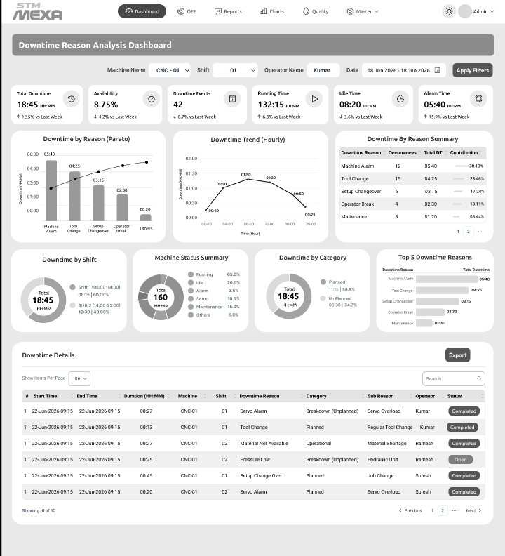

- The system shall display a Downtime Reason Analysis Dashboard with real-time downtime monitoring and KPI summaries.
- The system shall allow users to filter downtime records by Machine Name, Shift, Operator Name, and Date Range.
- The system shall display downtime KPIs including Total Downtime, Availability, Downtime Events, Running Time, Idle Time, and Alarm Time.
- The system shall display downtime by reason using Pareto and graphical charts.
- The system shall display hourly downtime trends for performance analysis.
- The system shall summarize downtime by reason, including total downtime and contribution percentage.
- The system shall display downtime distribution by Shift, Machine Status, and Downtime Category (Planned and Unplanned).
- The system shall display the Top 5 downtime reasons based on total downtime.
- The system shall maintain and display downtime details including Start Time, End Time, Duration, Machine, Shift, Downtime Reason, Category, Sub Reason, Operator, and Status.
- The system shall calculate and display downtime duration and machine availability automatically.
- The system shall provide search, sorting, filtering, and pagination for downtime records.
- The system shall generate and export downtime reports in Excel, CSV, and PDF formats.
- The system shall maintain complete downtime history and audit records for each machine.
- The system shall generate notifications for excessive downtime and recurring downtime events.
- The system shall provide real-time dashboard updates and drill-down capability for detailed downtime analysis.

Screen 7 - Operator Performance Dashboard

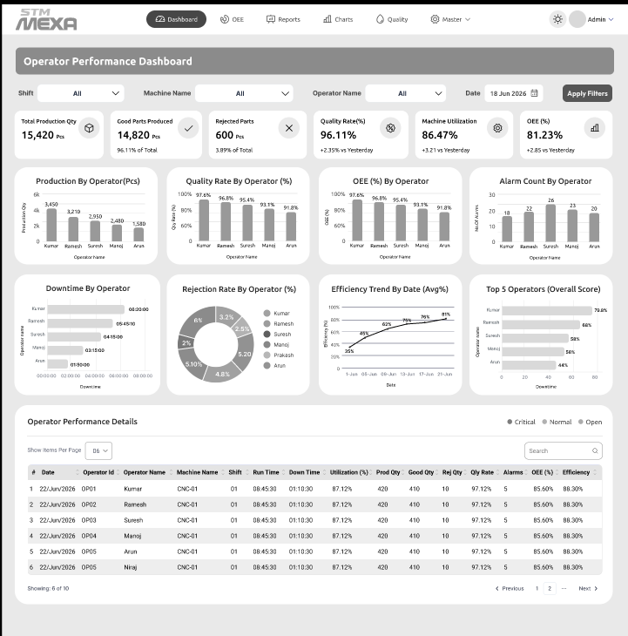

- The system shall display an Operator Performance Dashboard with real-time operator performance KPIs.
- The system shall allow users to filter operator performance data by Shift, Machine Name, Operator Name, and Date.
- The system shall display operator KPIs including Total Production Quantity, Good Parts Produced, Rejected Parts, Quality Rate, Machine Utilization, and OEE.
- The system shall display production quantity by operator using graphical charts.
- The system shall display Quality Rate (%) and OEE (%) for each operator.
- The system shall display Alarm Count and Downtime for each operator.
- The system shall display Rejection Rate, Efficiency Trend, and Top Performing Operators using graphical charts.
- The system shall maintain and display operator performance details including Date, Operator ID, Operator Name, Machine Name, Shift, Run Time, Down Time, Utilization, Production Quantity, Good Quantity, Rejection Quantity, Quality Rate, Alarm Count, OEE, and Efficiency.
- The system shall calculate and display operator efficiency, utilization, quality rate, rejection rate, and OEE automatically.
- The system shall rank operators based on overall performance metrics.
- The system shall provide search, sorting, filtering, and pagination for operator performance records.
- The system shall generate and export operator performance reports in Excel, CSV, and PDF formats.
- The system shall maintain complete operator performance history and audit records.
- The system shall generate notifications for operators with low efficiency, high rejection rate, or excessive downtime.
- The system shall provide real-time dashboard updates and drill-down capability for detailed operator performance analysis.

Screen 8 - OEE Dashboard

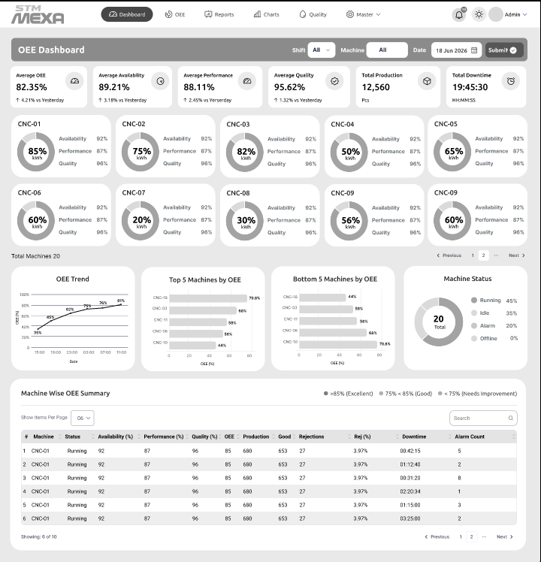

· The system shall display an OEE Dashboard with real-time Overall Equipment Effectiveness (OEE) metrics for all machines.
· The system shall allow users to filter OEE data by Shift, Machine, and Date.
· The system shall display OEE KPIs including Average OEE, Availability, Performance, Quality, Total Production, and Total Downtime.
· The system shall display machine-wise OEE, Availability, Performance, and Quality using graphical indicators.
· The system shall display OEE trends over time using graphical charts.
· The system shall display the Top 5 and Bottom 5 machines based on OEE performance.
· The system shall display the current machine status including Running, Idle, Alarm, and Offline.
· The system shall maintain and display machine-wise OEE details including Machine Name, Status, Availability, Performance, Quality, OEE, Production, Good Parts, Rejections, Rejection Rate, Downtime, and Alarm Count.
· The system shall calculate and display OEE, Availability, Performance, Quality, and Rejection Rate automatically.
· The system shall classify machine performance based on configurable OEE thresholds.
· The system shall provide search, sorting, filtering, and pagination for machine-wise OEE records.
· The system shall generate and export OEE reports in Excel, CSV, and PDF formats.
· The system shall maintain complete OEE history and audit records for each machine.
· The system shall generate notifications for machines with low OEE, excessive downtime, or high rejection rates.
· The system shall provide real-time dashboard updates and drill-down capability for detailed OEE analysis.

Screen 9 - Energy Dashboard

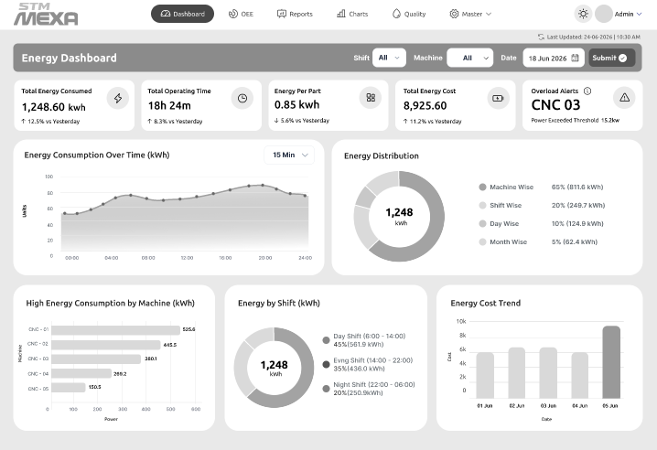

- The system shall display an Energy Dashboard with real-time energy consumption and performance metrics.
- The system shall allow users to filter energy data by Shift, Machine, and Date.
- The system shall display energy KPIs including Total Energy Consumed, Total Operating Time, Energy per Part, Total Energy Cost, and Overload Alerts.
- The system shall display energy consumption trends over time using graphical charts.
- The system shall display energy distribution by Machine, Shift, Day, and Month.
- The system shall display machine-wise energy consumption and identify high energy-consuming machines.
- The system shall display energy consumption by shift and compare energy usage across shifts.
- The system shall display energy cost trends over a selected time period.
- The system shall calculate and display Energy per Part, Total Energy Cost, and Operating Time automatically.
- The system shall generate overload alerts when machine energy consumption exceeds the configured threshold.
- The system shall provide search, filtering, and drill-down capabilities for energy analysis.
- The system shall generate and export energy reports in Excel, CSV, and PDF formats.
- The system shall maintain historical energy consumption records for each machine.
- The system shall generate notifications for excessive energy consumption, overload conditions, and abnormal energy usage.
- The system shall provide real-time dashboard updates for continuous energy monitoring and analysis.

Screen 10 - Program Transfer Software

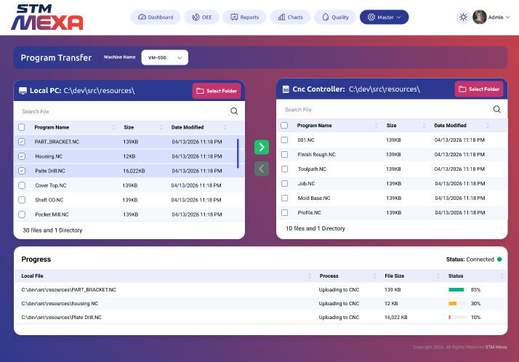

- The system shall provide a Program Transfer Dashboard for managing CNC program transfers between the Local PC and CNC Controller.
- The system shall allow users to select a CNC machine and browse program files from both the Local PC and CNC Controller.
- The system shall display program details including Program Name, File Size, and Date Modified.
- The system shall allow users to select one or multiple CNC program files for transfer.
- The system shall support uploading programs from the Local PC to the CNC Controller.
- The system shall support downloading programs from the CNC Controller to the Local PC.
- The system shall display the transfer progress, file size, process status, and completion percentage for each program.
- The system shall display the CNC controller connection status in real time.
- The system shall allow users to search and filter program files by name.
- The system shall prevent duplicate program transfers and provide overwrite confirmation when a program already exists.
- The system shall generate transfer logs including machine name, program name, transfer direction, user, date, time, and transfer status.
- The system shall provide role-based access control for program upload, download, and deletion operations.
- The system shall maintain complete program transfer history and audit records.
- The system shall generate notifications for successful, failed, or interrupted program transfers.
- The system shall provide real-time updates and detailed transfer status for all program transfer operations.

Screen 11- Company Management Software
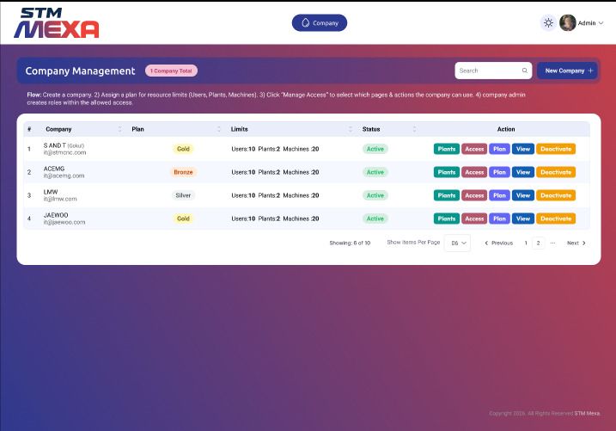
· The system shall provide a Company Management Dashboard to create and manage multiple companies.
· The system shall allow users to create, update, activate, deactivate, and view company information.
· The system shall allow users to assign subscription plans and resource limits including Users, Plants, and Machines for each company.
· The system shall display company details including Company Name, Plan, Resource Limits, and Status.
· The system shall allow users to manage company access permissions, modules, and features based on the assigned subscription plan.
· The system shall allow users to configure and manage company plants, machines, and users.
· The system shall automatically create a company administrator account with appropriate privileges during company registration.
· The system shall provide search, sorting, filtering, and pagination for company records.
· The system shall display the current company status as Active or Inactive.
· The system shall enforce subscription-based resource limits for users, plants, and machines.
· The system shall maintain complete company configuration and audit history.
· The system shall provide role-based access control for company management operations.
· The system shall generate notifications for company creation, plan changes, and account status updates.
· The system shall generate and export company management reports in Excel, CSV, and PDF formats.
· The system shall provide real-time updates and drill-down capability for detailed company management and administration.

Screen 12 - Machine Add Pop Up Screen
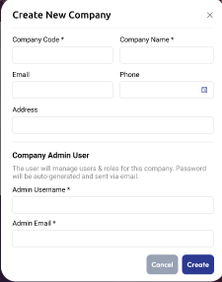
· The system shall allow authorized users to create a new company by entering the Company Code, Company Name, Email, Phone Number, and Address.
· The system shall validate all mandatory fields before creating a company.
· The system shall ensure that the Company Code is unique across the system.
· The system shall allow users to create a Company Administrator by entering the Administrator Username and Administrator Email.
· The system shall automatically generate a secure password for the Company Administrator during company creation.
· The system shall send the Company Administrator credentials to the registered email address.
· The system shall automatically assign default roles and permissions to the Company Administrator.
· The system shall validate the email address and phone number using configurable validation rules.
Screen 13 - Module Assign Plan
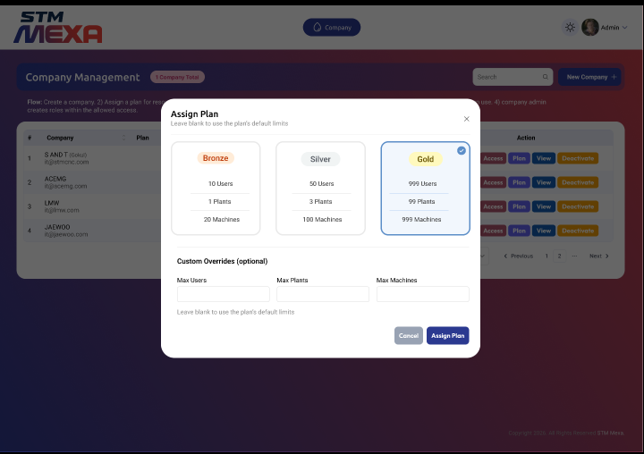

· The system shall allow authorized users to assign a subscription plan to a company.
· The system shall provide predefined subscription plans such as Bronze, Silver, and Gold with configurable resource limits.
· The system shall display the maximum number of Users, Plants, and Machines available for each subscription plan.
· The system shall allow users to override the default resource limits for Users, Plants, and Machines.
· The system shall validate that custom resource limits do not exceed the maximum limits permitted by the selected subscription plan.
· The system shall apply the selected subscription plan and resource limits to the company upon confirmation.
· The system shall update the company's subscription details and available resources automatically after plan assignment.
· The system shall allow users to modify or upgrade the assigned subscription plan at any time based on authorization.
· The system shall prevent assignment of invalid or expired subscription plans.
· The system shall display confirmation and error messages during the subscription plan assignment process.
· The system shall maintain a history of subscription plan assignments and changes for audit purposes.
· The system shall enforce the assigned resource limits when creating users, plants, and machines.
· The system shall restrict subscription plan assignment to authorized administrative users.
· The system shall notify users when a subscription plan is assigned, modified, or expires.
· The system shall make the assigned subscription plan effective immediately or from a configured effective date.

Screen 14 - Management Links

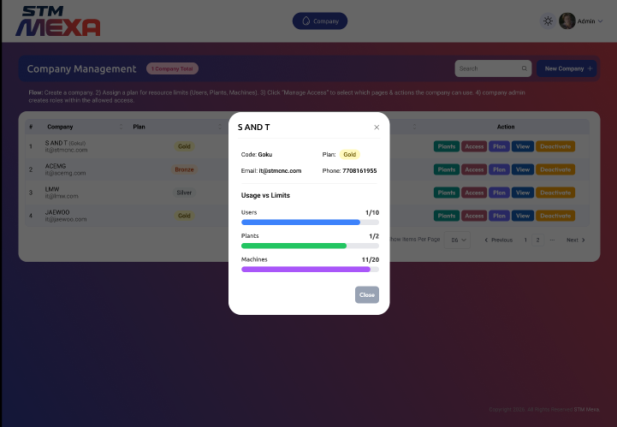

· The system shall display company information including Company Name, Company Code, Subscription Plan, Email Address, and Contact Number.
· The system shall display the configured resource limits for Users, Plants, and Machines assigned to the company.
· The system shall display the current resource usage against the allocated limits for Users, Plants, and Machines.
· The system shall calculate and display resource utilization as numerical values and graphical progress bars.
· The system shall highlight resource usage when the configured limits are reached or exceeded.
· The system shall update resource usage automatically as users, plants, and machines are added or removed.
· The system shall display the remaining available resources for Users, Plants, and Machines.
· The system shall restrict the creation of new resources when the allocated limits are exceeded.
· The system shall provide a detailed company resource utilization view to authorized users only.

Screen 15 : Manage Access

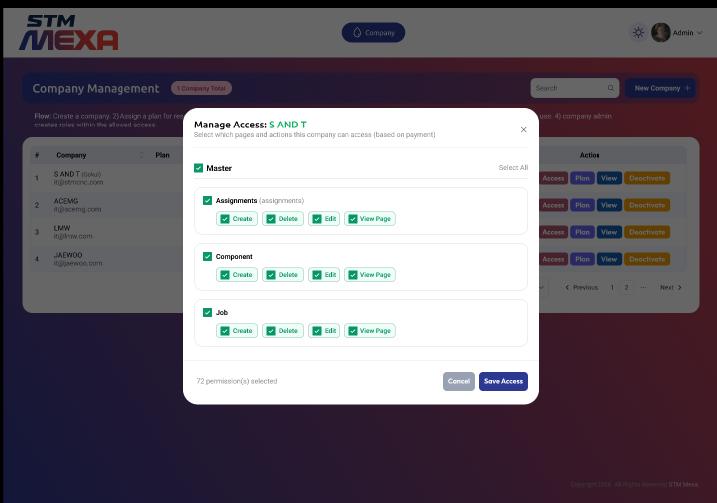

· The system shall allow authorized users to configure module and page-level access permissions for each company.
· The system shall display all available modules and their associated actions, including Create, Edit, Delete, and View.
· The system shall allow users to enable or disable access permissions for individual modules and actions.
· The system shall support selecting or deselecting all permissions for a module.
· The system shall display the total number of selected permissions before saving.
· The system shall allow access permissions to be assigned based on the company's subscription plan.
· The system shall prevent users from assigning permissions beyond those allowed by the assigned subscription plan.
· The system shall allow users to modify or revoke previously assigned access permissions.
· The system shall save and apply the configured permissions immediately after confirmation.
· The system shall enforce assigned permissions during user authentication and module access.
· The system shall provide role-based authorization to manage company access permissions.
· The system shall maintain an audit log of all permission assignments, modifications, and revocations.
· The system shall display confirmation and validation messages during the permission assignment process.
· The system shall allow users to cancel changes before saving without affecting existing permissions.
· The system shall provide a centralized interface for managing company module and action-level access permissions.

Screen 16 : User Management

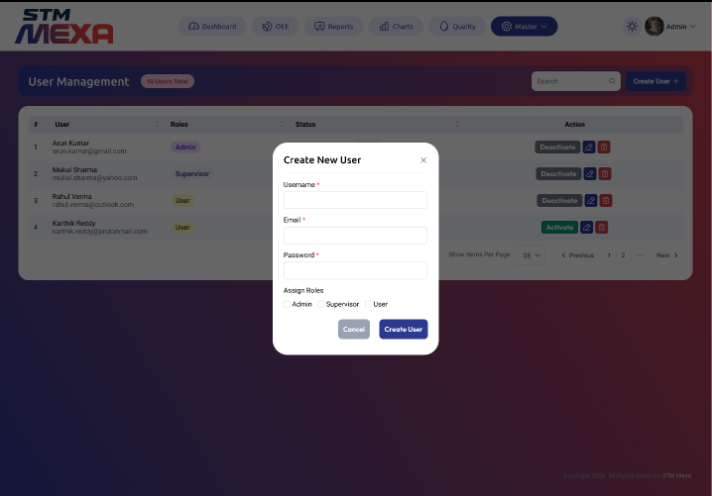

· The system shall allow authorized users to create new user accounts by entering Username, Email Address, Password, and Role.
· The system shall validate all mandatory fields before creating a user account.
· The system shall validate the uniqueness of the Username and Email Address before user creation.
· The system shall allow users to assign one or more roles such as Administrator, Supervisor, and User.
· The system shall create user accounts based on the configured company resource limits.
· The system shall allow authorized users to activate, deactivate, edit, and delete user accounts.
· The system shall display user details including Username, Email Address, Assigned Role, and Account Status.
· The system shall enforce role-based access permissions based on the assigned user role.
· The system shall provide search, sorting, filtering, and pagination for user records.
· The system shall display confirmation and validation messages during user management operations.
· The system shall maintain an audit log for user creation, modification, activation, deactivation, and deletion.
· The system shall generate notifications for user account creation, password changes, and account status updates.
· The system shall prevent the creation of users when the allocated user limit for the company has been reached.
· The system shall allow users to cancel the user creation process without saving any information.
· The system shall provide real-time updates to the User Management Dashboard after user account changes.

Screen 17 - Roles & Permission

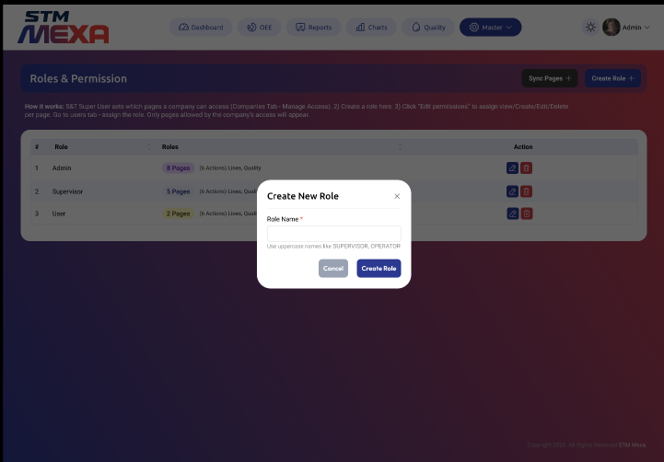

· The system shall allow authorized users to create, edit, and delete roles.
· The system shall require a unique Role Name before creating a new role.
· The system shall allow users to assign pages and action-level permissions (View, Create, Edit, and Delete) to each role.
· The system shall display the number of pages and permissions assigned to each role.
· The system shall restrict role permissions based on the company's assigned access permissions.
· The system shall allow users to synchronize available pages and permissions before role assignment.
· The system shall allow users to modify role permissions at any time based on authorization.
· The system shall prevent duplicate role names within the same company.
· The system shall enforce role-based permissions for all users assigned to a role.
· The system shall provide search, sorting, filtering, and pagination for role records.
· The system shall display confirmation and validation messages during role management operations.
· The system shall maintain an audit log for role creation, modification, deletion, and permission changes.
· The system shall prevent deletion of roles that are currently assigned to active users.
· The system shall allow users to cancel role creation or modification without saving changes.
· The system shall provide real-time updates to the Roles & Permissions module after role or permission changes.

Shift Calculations:
Planned Production time = Shift time (480 Min given)- Break (80 Min given) Operating Time = Planned Production time – Sum (Downtimes)

OEE Calculations
Availability = Operating Time/Planned Production time
Performance = (Total Pieces/Operation Time)/Ideal run rate (Manual Entry by Part Program) Good Pieces = Total Pieces – Rejected Pieces (Manual Entry per shift)
Quality = Good Pieces/Total Pieces OEE= Availability*Performance*Quality Hour Calculation:
Every 1 Hour the Performance Will be calculated and saved with time stamp

PROJECT PHASES & DELIVERABLES

Phase 1 (150 Days Total)
  - 100 Days Development
  - 50 Days Testing Deliverables include:
  - Web portal – Login, Dashboard, OEE, Reports, Program Transfer, Alarm Notifications, AI
  - PLC communication layer
  - Live machine monitoring
  - Database & APIs
  - Documentation
  - Source code handover

DEVELOPMENT TEAM & RESPONSIBILITY
Consultant may engage:
  - Gokul – Backend Developer
  - Ramesh – Frontend Developer
  - Santhosh – UI/UX Designer
  - Santhosh Kumar – Tester
  - Archana – Mobile App Developer
  - Kalai - Backend Developer
All freelancers shall sign:
  - NDA
  - IP Assignment
Consultant is fully responsible for deliverables.

PROJECT TIMELINE

Stage | Duration
Requirement Finalization | Need to Complete all
Development | 100 Days
Testing & Stabilization | 50 Days
Total | 150 Days

COMMERCIALS & PAYMENT TERMS
Total Cost: ₹14,00,000

Milestone | % | Payment
Kickoff | 50% | Project Start
Development Completion | 30% | Major Modules Done
Final Delivery | 20% | Go-Live
AMC Support | - | 3 Years

DEPENDENCIES (COMPANY RESPONSIBILITY)
Company shall provide:
  - Server hardware (Windows Server)
  - Network connectivity
  - OPC UA license for Siemens / MT Connect for Mitsubishi (if required)
  - CNC OEM engineer support
  - Energy Meters/ Gateways/ Switches / Hardware
  - Shop floor wiring & IT setup

OUT OF SCOPE
  - Hardware (Routers, Gateways, Energy meters)
  - Third-party software issues
  - OEM service charges
  - Shop-floor installation work
  - Additional features not listed in Annexure A

ACCEPTANCE CRITERIA
System is accepted when:
- All features in Annexure A delivered
- No major defects remain
- Final testing completed
- Written acceptance is given

INTELLECTUAL PROPERTY RIGHTS (IPR)
  - All source code, designs, APIs, databases belong to S&T Machinery Pvt. Ltd.
  - Consultant assigns all IP to Company.
  - Consultant cannot reuse, resell, license, or modify for third-party use.
  - Work is classified as Work Made for Hire.

CONFIDENTIALITY
  - All passwords, CNC data, architecture, designs are confidential.
  - Consultant cannot disclose to any third party.
  - Obligation continues for 5 years post-termination.

NON-SOLICITATION
For 12 months, Consultant shall not:
  - Hire Company employees
  - Contact Company customers
  - Sell similar PMS/I4.0 solutions based on Company code

CHANGE REQUEST PROCEDURE
Any extra feature or scope change:
  - Must be written
  - Must be approved by both parties
  - Will be billed separately
  - Timeline will extend

SUPPORT & WARRANTY
  - AMC - 3 Years AMC Support should be provide, If any reports customisation, Colors, lables, Machines live Dashboard stoppage, Dashboard Contents, Go-Live.
  - AMC is not applicable for New Screens or New Idea’s Development
  - Enhancements will be charged
  - Consultant not responsible for:
    - Network failure
    - Hardware faults
    - Server crashes
    - Machine/CNC changes

TERMINATION
Either party may terminate with:

30 days written notice
Upon termination:
  - All work done belongs to Company
  - Consultant must hand over source code
  - All passwords and confidential data must be returned

PENALTIES & DAMAGES
If Consultant breaches:
  - Confidentiality
  - IPR
  - Tries to resell PMS/I4.0
  - Reuses source code He shall pay:

₹25,00,000 (Twenty-Five Lakhs) as Liquidated Damages
Company may also claim additional legal damages.

GOVERNING LAW & JURISDICTION
Governed by:
  - Indian Contract Act, 1872
  - IT Act, 2000
  - Courts of Coimbatore have exclusive jurisdiction

ENTIRE AGREEMENT
This document supersedes all previous proposals, meetings, WhatsApp discussions, or emails.

SIGNATURE

For S&T Machinery Private Limited Name : Saravanan S
Designation : Head - IOT Dev Signature : Date :

For Consultant Mr. Gokul
Signature :

Date :
Mr. Santhosh
Signature :

Date :
Ms. Archana
Signature :

Date :
Mr. Kalai
Signature :

Date :
Mr. Ramesh
Signature :

Date :
Mr. Santhosh Kumar
Signature :

Date :

